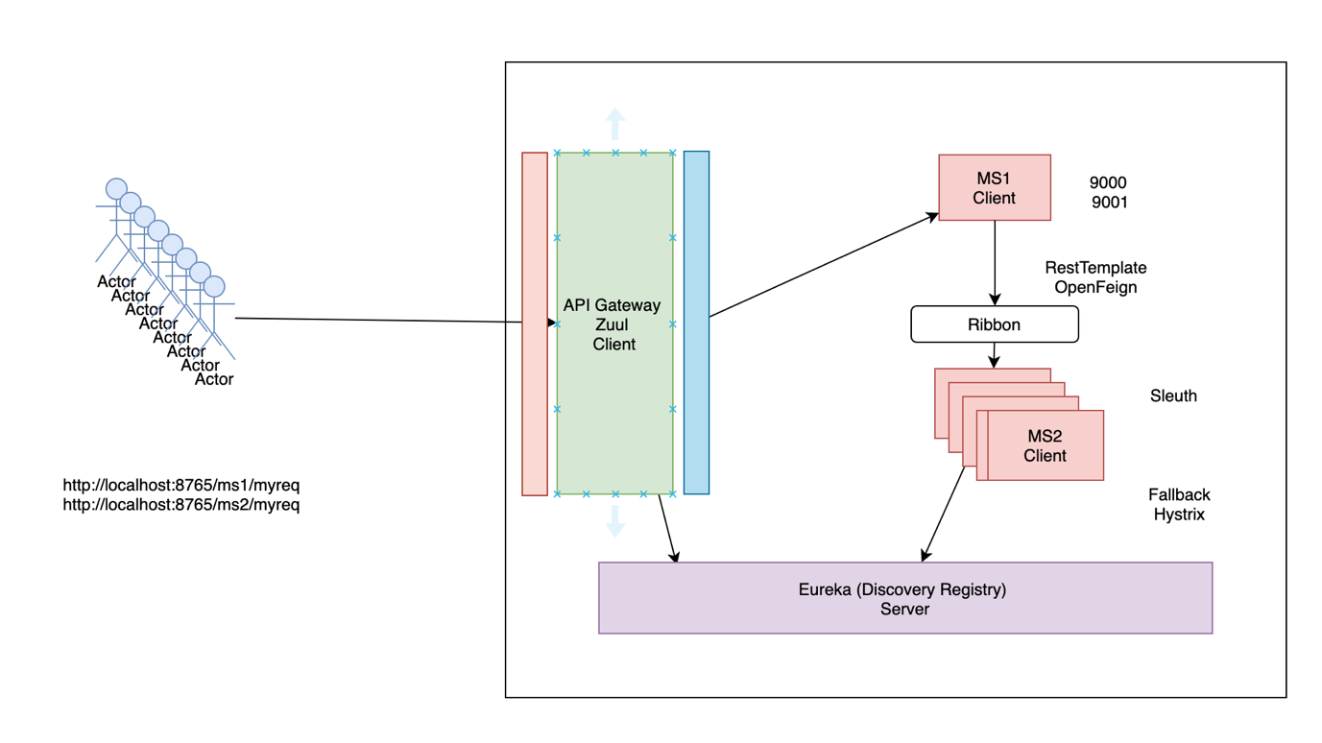

1. Start Eureka
2. Start ZUUL

@Configuration

@EnableZuulProxy

@EnableEurekaClient

@SpringBootApplication

**public** **class** ApiGatewayApplication {

**public** **static** **void** main(String[] args) {

SpringApplication.*run*(ApiGatewayApplication.**class**, args);

}

@Bean

**public** PreFilter preFilter() {

**return** **new** PreFilter();

}

@Bean

**public** PostFilter postFilter() {

**return** **new** PostFilter();

}

}

1. Start product-Service
2. Start product-review-service

<http://localhost:9100/products>

<http://localhost:9100/product/101>

<http://localhost:9200/review/101>

We have ZUUL

Zuul – 8765 -> Registered on Eureka 8761

<http://localhost:8765/productservice/products>

product-review-service

some reviews

<http://localhost:8765/productservice/products/101>

<http://localhost:8765/productservice/product-feign/101>

1. zuul (8765) -> eureka (productservice) -> 9100 -> product-feign/101 -> Open Feign (Annotated As proxy) – productreviewservice -> eureka -> 9200 -> /review/{id} -> invokes